Project Title: UniMatch: Intelligent Foreign University Admission & Eligibility Management System

Group No:08, Lab Section: C2,
Spring 2026
ID | Name
024231000534155 | Md Sharwer Hossain Shahil
221-35-949 | Shahariar Ahmed
0242310005341464 | Md Molla Golam Mostafa

Software Requirement Specification (SRS)

Introduction

In simple terms, UniMatch is a smart digital assistant that helps students find the best and most suitable universities abroad based on their results (CGPA) and language skills (IELTS/MOI). It simplifies the complex process of selecting the right educational institution according to your profile.

1.1 Problem: What kind of suffering do students currently face?
Even if they have a dream of studying abroad, choosing the right university is quite difficult. Problems that students currently face
Mountain of information: It is time-consuming to visit hundreds of university websites to collect information.
Confusion about eligibility: Many people struggle to understand which university they can apply to with their CGPA or IELTS score.
Wrong application: Many times, students apply to places where they do not have a chance of admission, resulting in wasting both money and time.
Lack of integrated platform: There is no place where all the information is available together.

1.2 Objective: Why was UniMatch created?
The main goal of this system is to bring the admission process into the palm of your hand through technology. Its main objectives are:
Profile Creation: Students can easily create a profile with their results and qualification information.
Automatic Matching: The system will automatically find out which universities match your score.
All information in one place: All world-renowned universities and their admission rules will be available on a central platform.
Simplify the application process: The facility to apply to the university of your choice directly from the platform.
Admin Panel: So that university authorities or administrators can easily verify and shortlist the applications.

1.3 Scope: What will this system do and what will it not do?
Benefits that you will get and what you will not get by using UniMatch:
Key features of the system (which will be there):
Easy registration and login facility.
Personal and academic profile management.
Huge database of universities.
Auto-matching and filter options according to qualification.
Facility to apply directly online and track the status of the application.
System limitations (which will not be there):
Guarantee of admission: This is only a means of application; the final decision on admission will be taken by the concerned university.
Visa processing: No visa related services will be provided here.
Financial transactions: No scholarship payments or any kind of financial transactions will be made on this platform.
Not a government portal: This is not an alternative to any government admission portal, but rather an independent supporting platform.

Design and Implementation Constraints

The UniMatch system is built on a modern full-stack architecture designed for high performance, security, and scalability. By leveraging the PERN/MERN stack, the system ensures a seamless experience for both students and administrators.
2.1 Programming Languages & Frameworks
We utilize a unified JavaScript ecosystem to streamline development and ensure the system can handle a growing database of universities and users.
- Frontend: React.js
  - Why React.js? It uses a Component-Based Architecture, allowing us to build reusable UI elements. Its Virtual DOM ensures that the interface updates instantly without reloading the page, providing a fluid user experience.
  - Styling & UI: We utilize Tailwind CSS (or Bootstrap) to implement a Mobile-First Responsive Design. This ensures that students can check their eligibility from any device, whether it's a smartphone, tablet, or desktop.

- Backend: Node.js & Express.js
  - Why Node.js? Its Non-blocking I/O model allows the server to handle multiple simultaneous requests efficiently. Since both the frontend and backend use JavaScript, data exchange is simplified, and development cycles are faster.
  - Logic Layer: Express.js provides a minimalist and flexible framework to manage complex routing and eligibility-matching algorithms.

2.2 Data Management & Infrastructure
For a system dealing with sensitive academic data and complex admission criteria, reliability and structured data organization are non-negotiable.
- Relational Database (PostgreSQL / MySQL):
  - Unlike NoSQL, a Relational Database Management System (RDBMS) is ideal for UniMatch because it handles structured relationships between student profiles, test scores (IELTS/MOI), and university-specific requirements with high Data Integrity.
- API Architecture (RESTful APIs):
  - The frontend and backend communicate via REST APIs. This "decoupled" approach means that in the future, if we decide to launch a mobile app (Android/iOS), it can easily connect to the existing backend without any major modifications.
- Cloud Deployment & Hosting:
  - The system will be hosted on professional cloud platforms like Vercel, Render, or Railway. These platforms offer Continuous Integration/Continuous Deployment (CI/CD), ensuring the platform remains online 24/7 with automatic updates and high availability.

2.3 Technical Summary (At a Glance)
Category | Technology Used | Strategic Advantage
Language | JavaScript (ES6+) | Unified code across the entire stack.
Frontend | React.js | High interactivity and reusable components.
Styling | Tailwind CSS | Modern, clean, and fully responsive UI.
Backend | Node.js / Express.js | Scalable and fast server-side processing.
Database | PostgreSQL / MySQL | Secure and structured data management.
Communication | RESTful API | Flexible integration with future platforms.
Hosting | Vercel / Render | High uptime and seamless cloud deployment.

User Classes and Characteristics

There will be three types of users in the UniMatch system. Each user has different roles, functions, and access levels. Their responsibilities and permissions are described below in simple terms.

3.1 Primary Users – Students
Students are the main users of the UniMatch platform. Their primary goal is to find and apply to foreign universities that match their academic qualifications.

Key Capabilities and Features
Profile Creation
Students can create their own accounts and upload personal information and profile photos.
Academic Information Submission
Students can upload their academic details such as CGPA, IELTS score, and MOI (Medium of Instruction) certificate.
Smart Matching
The system automatically analyzes the student's academic profile and shows foreign universities that match their qualifications.
Application and Tracking
Students can apply online to their preferred universities and monitor the application status (e.g., Pending, Under Review, Accepted, Rejected) through their personal dashboard.

3.2 System Administrators (Admin)
Administrators are responsible for managing and controlling the system. They ensure that the platform information is accurate and that students receive reliable services.

Core Capabilities and Features
University Management
Admins can add new universities, update existing university information, or remove universities from the system.
Eligibility Determination
Admins set the minimum CGPA, IELTS score, and other requirements for each university in the system.
Application Review
Admins review applications submitted by students and update their status accordingly.
User Control
Admins can manage user accounts, resolve technical issues, and take action if users violate system rules.

3.3 Guest Users (Optional)
Guest users are visitors who want to explore the system without creating an account.

Core Capabilities and Features
General Browsing
Guest users can view the list of universities from different countries and explore available programs.
Information Search
They can search for universities by country name or subject/field of study.
Limitations
Guest users can only view information. To apply for universities or access full features, they must register as a student.

User Access Summary (At a Glance)
Feature | Student | Admin | Guest
Create Profile | ✅ | ✅ | ❌
University Search | ✅ | ✅ | ✅
Add/Update University Information | ❌ | ✅ | ❌
Submit Application | ✅ | ❌ | ❌
Review / Manage Applications | ❌ | ✅ | ❌

Functional Requirements (FR)

These are the core features required for the UniMatch system to function properly. Without these features, the system would be incomplete.

ID | Feature Name | Detailed Description | Users | Priority
FR-1 | Registration | Create a new account using name, email, and password. | Student, Admin | High
FR-2 | Login System | Securely log in to the system using email and password. | Student, Admin | High
FR-3 | Profile Management | Students can update their name, profile photo, and personal information. | Student | High
FR-4 | Academic Information | Upload academic details such as CGPA, IELTS score, and MOI certificate. | Student | High
FR-5 | Smart Search | Search universities by country, subject, or admission requirements. | Student, Admin, Guest | High
FR-6 | Smart Matching | Automatically display universities that match the student’s academic qualifications. | Student | High
FR-7 | Information Management | Add or update university information and admission requirements. | Admin | High
FR-8 | Submit Application | Students can apply directly to their preferred university from the platform. | Student | High
FR-9 | Application Tracking | Students can view the current status of their applications (e.g., Pending, Under Review, Accepted). | Student | High
FR-10 | Application Review | Admin verifies student applications and updates their status. | Admin | High

4.2 Supporting Features (Medium & Low Priority)
These features improve the usability and user experience of the system but are not essential for the basic functionality.

ID | Feature Name | Detailed Description | Users | Priority
FR-11 | Document Upload | Students can upload scanned copies of transcripts or certificates. | Student | Medium
FR-12 | User Dashboard | Students can view their profile summary, matched universities, and applications in one place. | Student | Medium
FR-13 | Notification System | The system notifies users when their application status changes. | Student | Medium
FR-14 | Guest Browsing | Guest users can view general university information without logging in. | Guest | Low

Non-Functional Requirements

This section discusses how the system will behave in real-world use. It focuses on performance, security, usability, reliability, and scalability. These requirements describe how fast the system runs, how secure it is, and how easily users can interact with it.

5.1 Performance: How fast is the system?
In real life, users often get frustrated when a website takes too long to load. Therefore, the UniMatch system is designed to provide a fast and responsive experience.
Fast Loading
The dashboard or university list will appear on the screen within 2–3 seconds.
Search Speed
Results will be displayed instantly (within less than 3 seconds) after a user searches for any university.
Multi-User Support
Even if hundreds of students use the website simultaneously, the system will continue to perform smoothly without slowing down.

5.2 Security: How secure is the information?
Since students may upload important documents such as passports, transcripts, and personal information, security is a top priority.
Password Protection
User passwords will not be stored directly. Instead, they will be encrypted using strong technologies such as bcrypt.
Secure Communication
The website will use the HTTPS protocol so that data transmitted between the user and the server cannot be intercepted by hackers.
Access Control
Different users will have different permissions. For example, students cannot access admin information, and users will only be able to access the data they are authorized to view.
Document Security
All uploaded certificates and transcripts will be stored on a secure server with restricted access.

5.3 Usability: How easy is the system to use?
The UniMatch system is designed so that anyone with basic technology knowledge can use it easily.
Clean Design
The interface is designed to be simple and clean, avoiding unnecessary complexity.
Mobile Friendly
The website will display properly on laptops, tablets, and smartphones, ensuring accessibility across different devices.
Easy Instructions
If users make mistakes (such as entering an incorrect email), the system will provide clear messages in simple English or Bengali explaining the problem.

5.4 Reliability & Scalability
Always Available
The system aims to maintain 99% uptime, ensuring that students can access the platform and apply to universities at any time.
Data Backup
Automatic daily or weekly backups will be performed to ensure that user data is not lost if there is a server problem.
Future Expansion
Although the platform may initially include information for a limited number of universities, it will be designed to support thousands of universities and additional countries in the future.

Non-Functional Requirements at a Glance (Summary Table)
Category | Key Feature | Goal
Performance | Response Time | Page loading within 3 seconds
Security | Data Protection | Encryption and HTTPS communication
Usability | Device Compatibility | Works smoothly on mobile and PC
Reliability | Uptime | Maintain 99–99.9% system availability
Scalability | Expansion | Ability to support thousands of users and universities

System Design Diagrams (for UniMatch)

Visual diagrams help explain how users interact with UniMatch and how data is structured in the system.

6.1 Use Case Diagram
Actors:
- Student – Searches universities, applies, and checks admission status.
- University Admin – Manages applications, updates admission results.
- System – Sends notifications and stores application data.
Use Cases:
- Search Universities – Student searches available programs.
- Apply to University – Student submits an application.
- Check Admission Status – Student views application outcome.
- Manage Applications – University Admin reviews and updates applications.
- Send Notifications – System notifies students of updates.
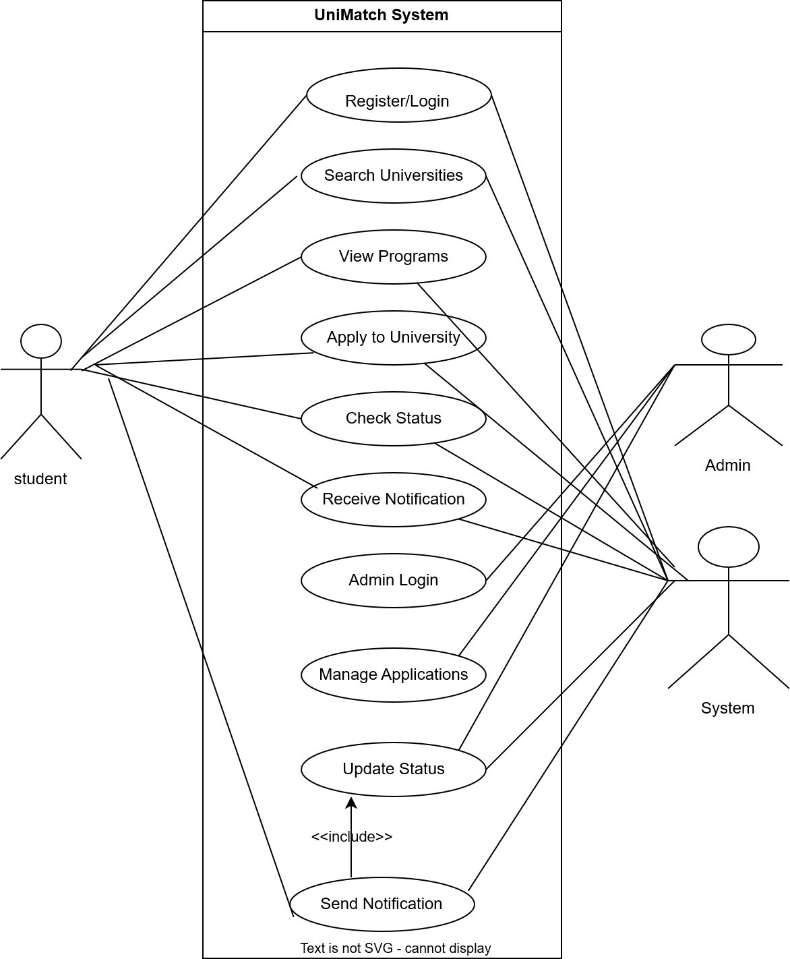

Relationships:
- Student performs Search Universities, Apply to University, Check Admission Status.
- University Admin performs Manage Applications.
- System performs Send Notifications triggered by application updates.
6.2 Entity Relationship Diagram (ERD)
Entities & Attributes:
- Student
  - Student_ID (PK)
  - Name
  - Email
  - Phone
  - CGPA
- University
  - University_ID (PK)
  - Name
  - Location
  - Programs
- Application
  - Application_ID (PK)
  - Student_ID (FK)
  - University_ID (FK)
  - Status
  - Submission_Date

- Notification
  - Notification_ID (PK)
  - Student_ID (FK)
  - Message
  - Timestamp
- Program
  - Program_ID (PK)
  - University_ID (FK)
  - Name
  - Field
  - Requirements
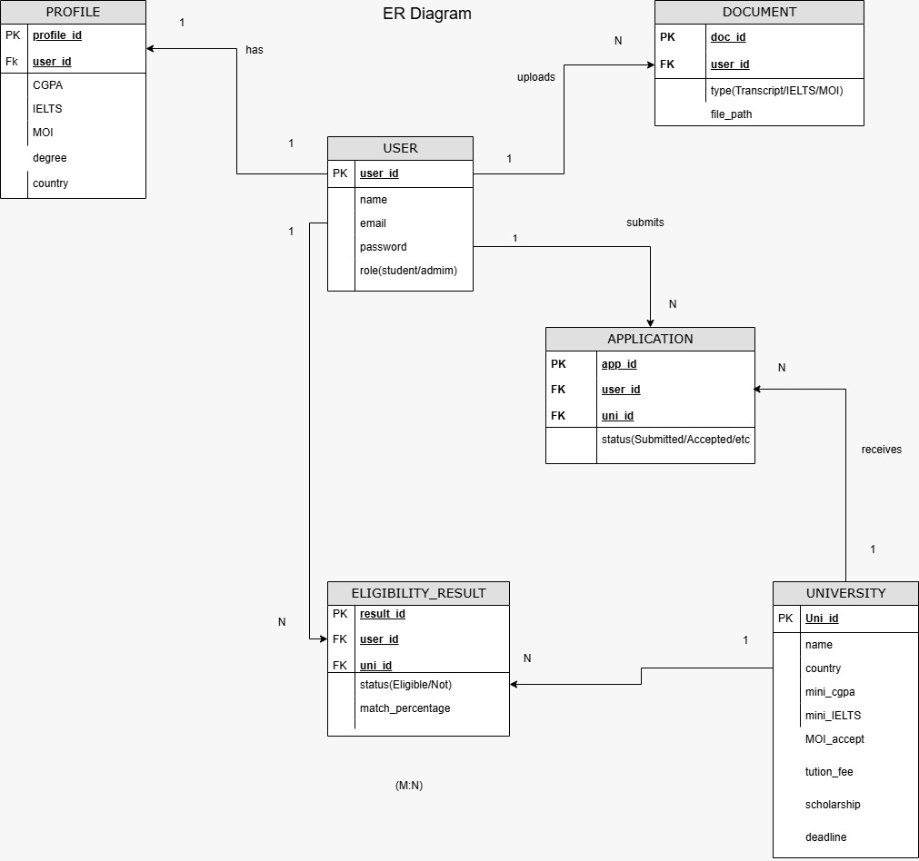
Relationships & Cardinality:
- Student → Application: 1:N (One student can submit many applications)
- University → Program: 1:N (One university can have many programs)
- Application → Notification: 1:1 (Each application can trigger one notification)
- Student → Notification: 1:N (A student can receive many notifications)
Activity Diagram :
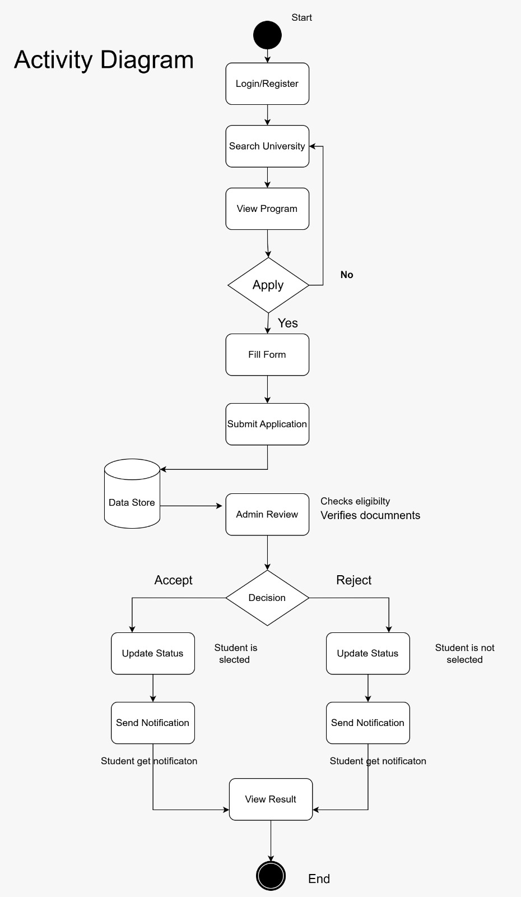

Team Member Responsibility Matrix

Member Name | ID | Primary Responsibilities | Contribution / Notes
Shahil | [0242310005341255] | Backend API development, Database Schema, Overall System Design, Majority of Documentation | Lead developer & main contributor (~90% of work). Handled core coding, database design, and report drafting.
Tomal | [221-35-949] | Frontend UI/UX, State Management, Integration | Assisted with frontend design, connected API endpoints, tested UI functionality.
Mostofa | [0242310005341464] | Frontend Support, Testing | Helped with UI tweaks, testing, and minor documentation support.
Individual Functional Requirements (per member):
- Shahil:
  - Designed database schema & ERD
  - Developed API endpoints for student, university, and application data
  - Implemented notification logic and admission status tracking
  - Drafted majority of report and diagrams
- Tomal:
  - Designed responsive frontend UI for student dashboard
  - Managed state for search, applications, and notifications
  - Integrated frontend with backend APIs
- Mostofa:
  - Assisted in testing UI and backend functionality
  - Minor frontend enhancements and bug fixes

